Contents
1. Introduction 2
2. Pre-Production 3
Moodboard 3
3. Research 4
4. Optimization 5
5. Modelling Process 6
• Chair 6
• Sofa 11
• Coffee Table 16
• Mini fridge 20
• Wardrobe 24
• Bar Chair 28
• Table 33
• Barrel 37
• Book 43
5. UV unwrapping 47
• Barrel 47
• Bar chair 48
• Coffee Table 49
• Books 50

Introduction
The upcoming project primarily focuses on exploring on the topic of how meshes are optimized for the games by using tools and 3d software. Game development is increasingly being relied on the efficiency and performance of the processor. The aim of the project is to create a detailed 3d environment while ensuring optimization for real time application and rendering.
This project will utilize Maya and Adobe Substance painter to model and texture the environment to create detailed and visually appealing assets. It will use methods and techniques like reducing the polycount, baking of mesh from high poly to low poly by baking textures and implementing level of detail (LOD) systems to balance visual detail and performance.
The goal of this project is to provide insights into creating efficient, high quality game environments with use of as less polygon as possible. Ultimately, it shows the importance of balancing visually appealing detail with performance friendly environment and optimized for different hardware platforms.

Pre-Production

Moodboard
This mood board shows a clean, modern corporate setting for a tactical FPS game. It includes eight images of office buildings, quiet lobbies, stairwells, and boardrooms. The colors are mostly gray, blue, and neutral tones, giving everything a sleek and serious look. There are no people in the scenes, which makes the spaces feel calm but a little tense like something could happen at any moment. The buildings have a sharp, professional design that feels organized and high-tech. Overall, it sets the mood for action in a place that looks controlled on the outside but could turn dangerous fast.
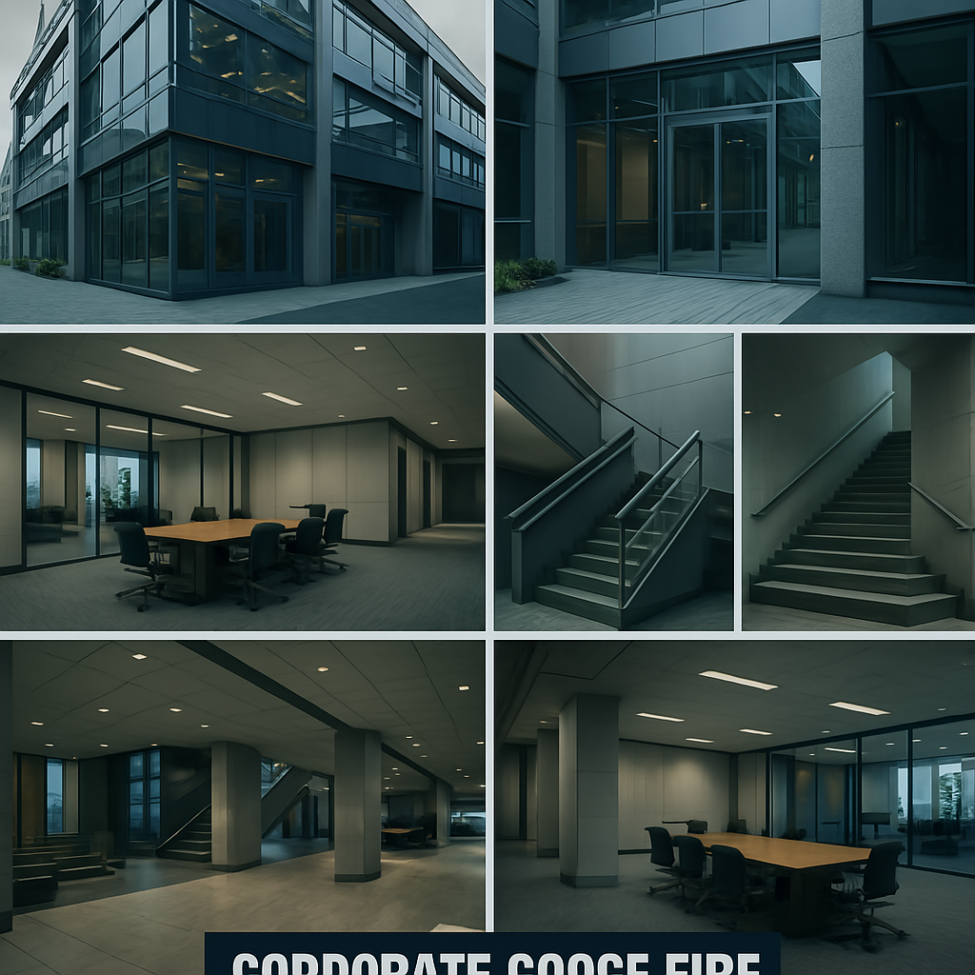

Research
The upcoming project primarily focuses on exploring on the topic of how meshes are optimized for the games by using tools and 3d software. Game development is increasingly being relied on the efficiency and performance of the processor. The aim of the project is to create a detailed 3d environment while ensuring optimization for real time application and rendering.
This project will utilize Maya and Adobe Substance painter to model and texture the environment to create detailed and visually appealing assets. It will use methods and techniques like reducing the polycount, baking of mesh from high poly to low poly by baking textures and implementing level of detail (LOD) systems to balance visual detail and performance.
The goal of this project is to provide insights into creating efficient, high quality game environments with use of as less polygon as possible. Ultimately, it shows the importance of balancing visually appealing detail with performance friendly environment and optimized for different hardware platforms.

Optimization
One of the most important things to remember while making models and props for the game is the proper optimized topology. Game topology usually means that we must get as much detail as possible with as low poly count as possible. Lower the poly count the smoother the game will be. When we lose polycount it becomes difficult to capture all the detail of the model. In that time, we use texturing for the detail capture. It is very important for game to have as low topology as possible as it will take less time to render, and game will be more efficient. Game topology also depends on the type of assets that we are dealing with. For example, when it comes to building and other models that won’t be animated in the production, we can minimize the polygon and keep clean geometry. Poorly designed model with unnecessary complex topology can result in less optimized game and poor experience for the user.
Some of the software like unreal and Maya support (LOD) systems in which the high-resolution version of the mesh can be replaced by the low-resolution mesh at a distance so it can be modelled in low poly count

5. Modelling Process

Chair
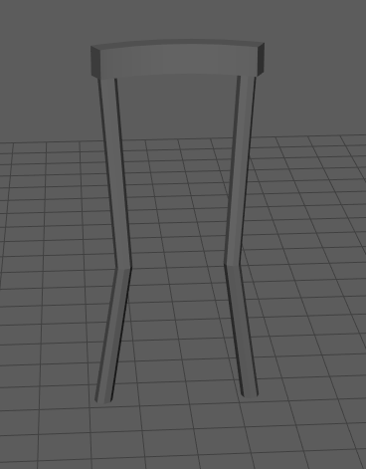

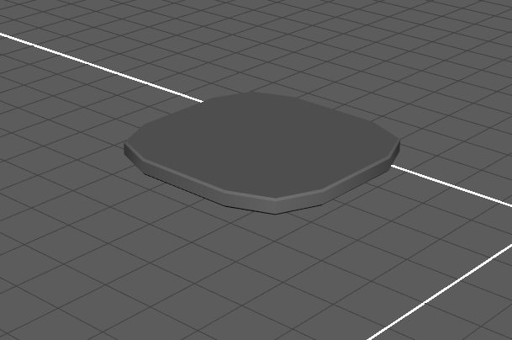

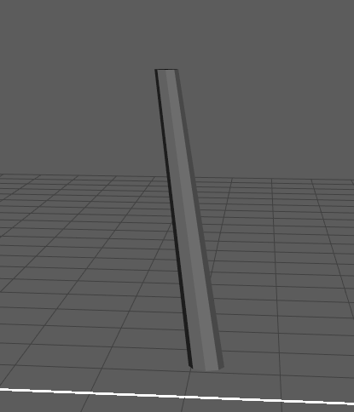

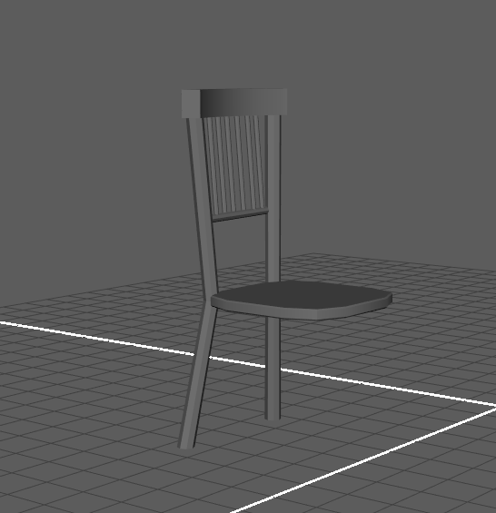

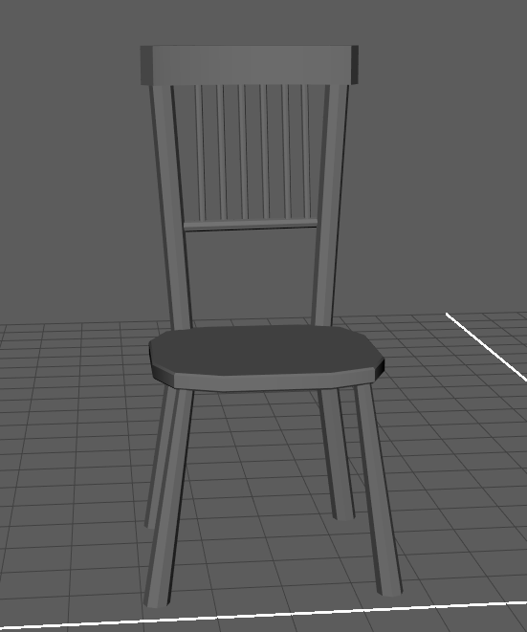

Sofa

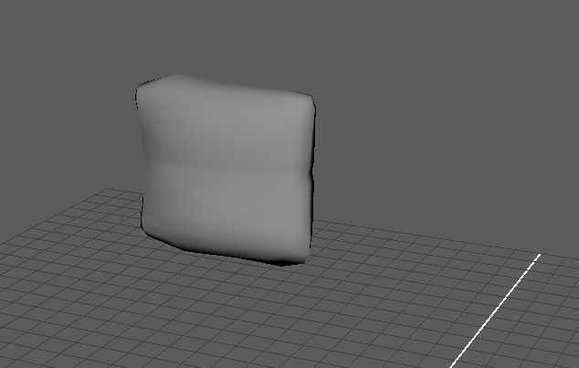

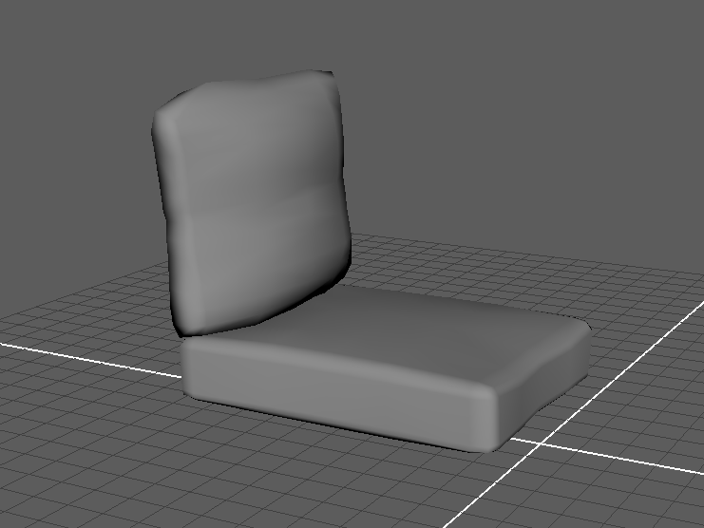

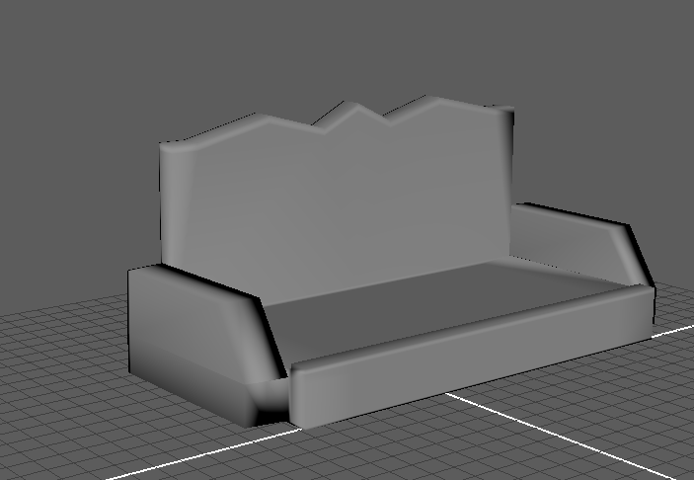

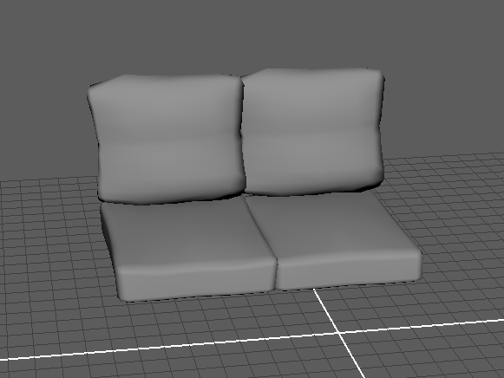

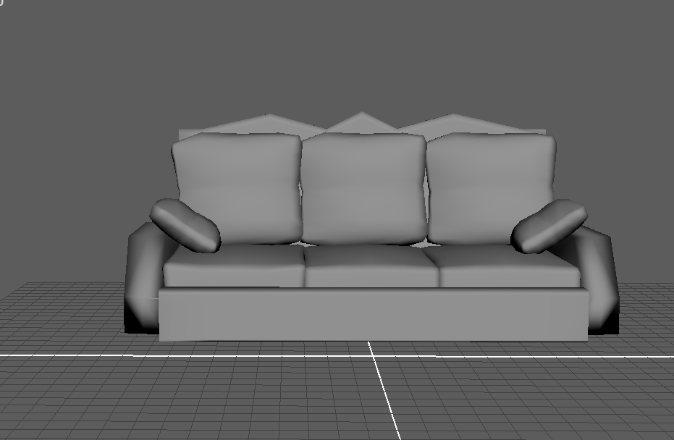

Coffee Table

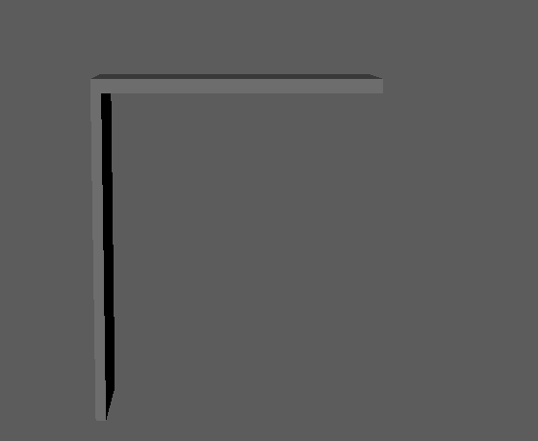

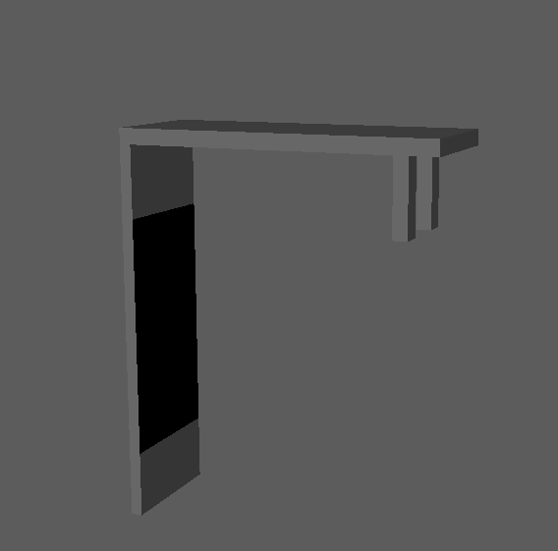

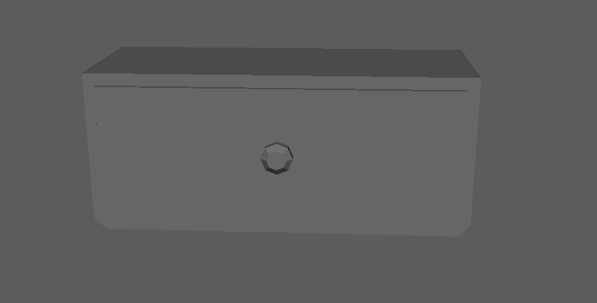

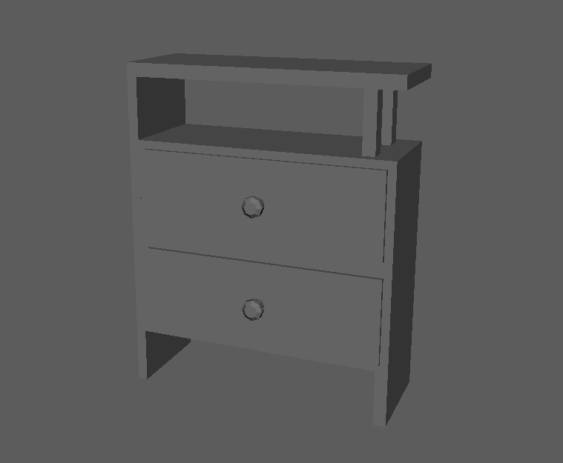

Mini fridge

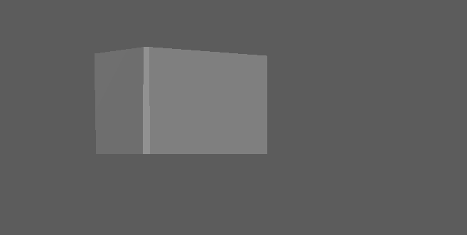

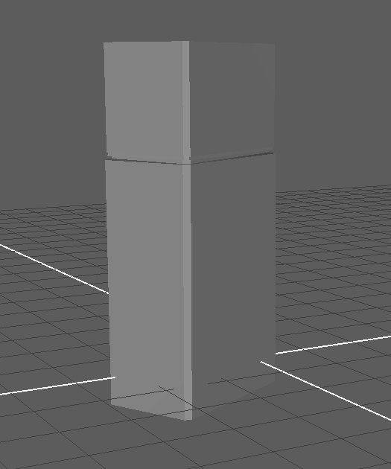

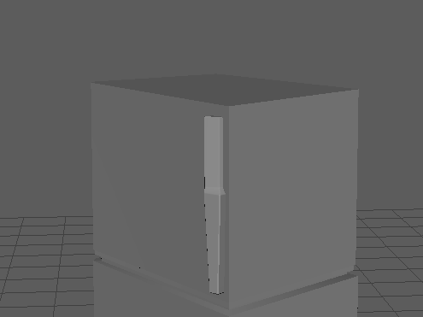

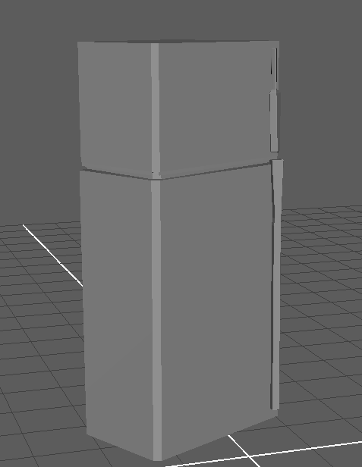

Wardrobe
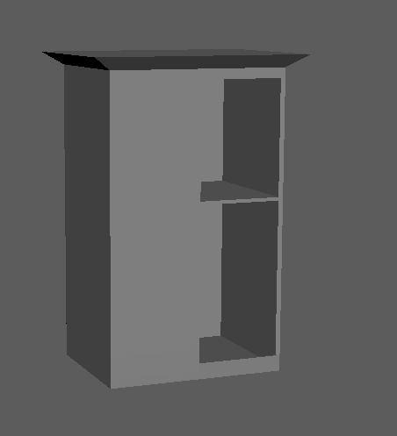

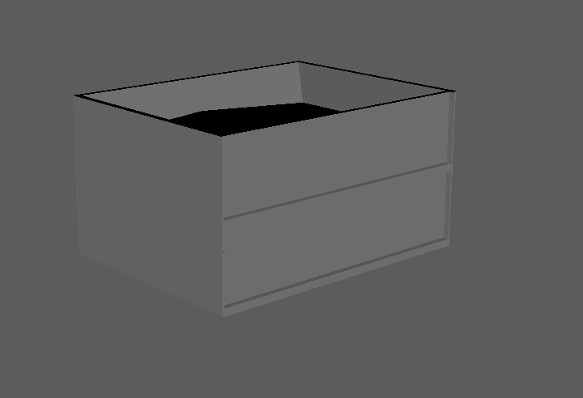

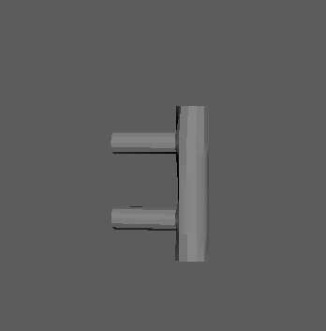

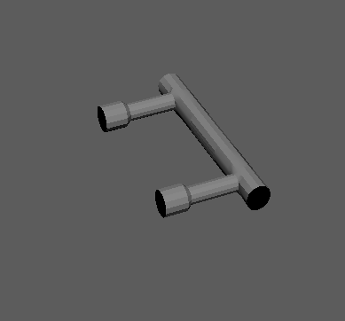

Bar Chair

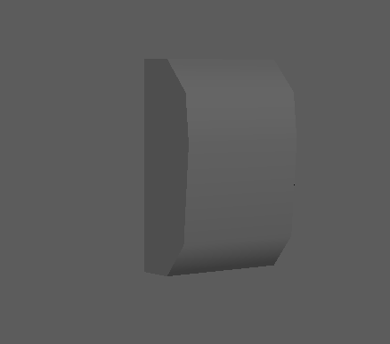

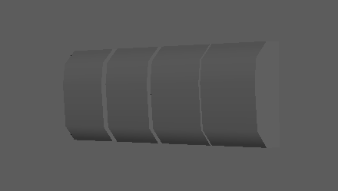

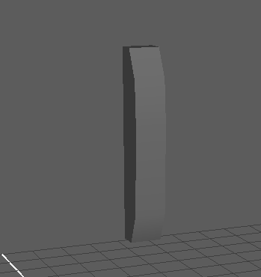

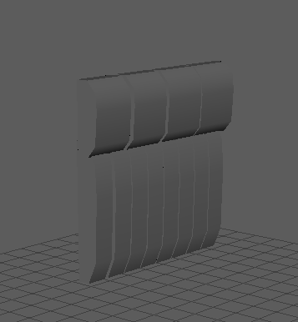

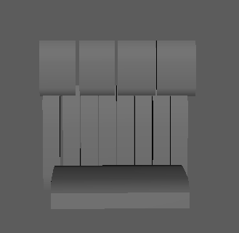

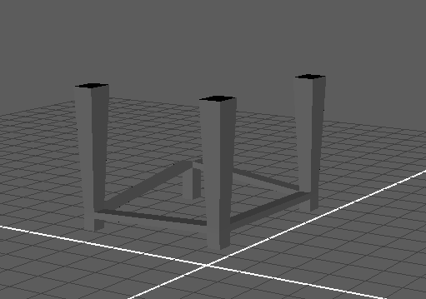

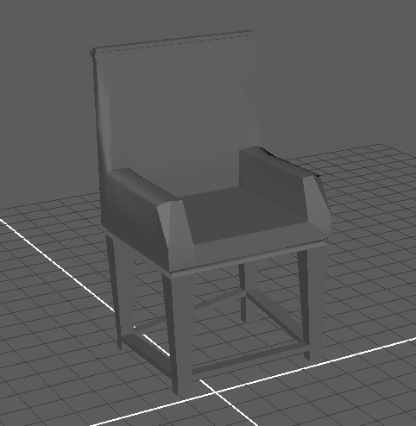

Table
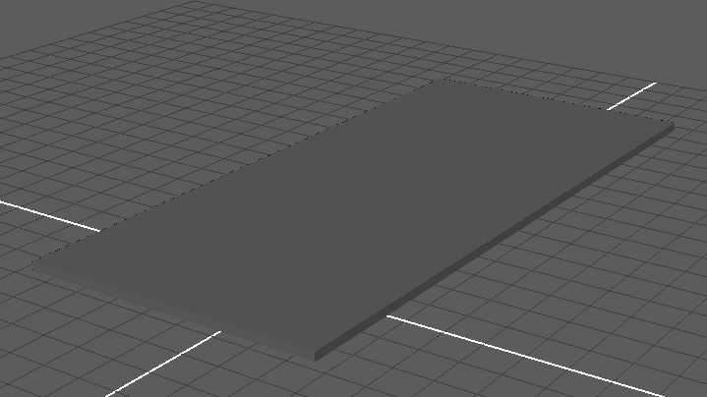

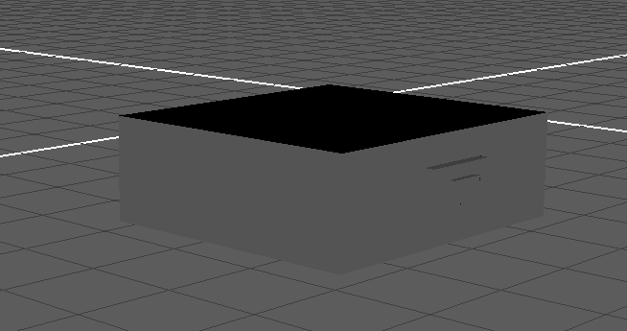

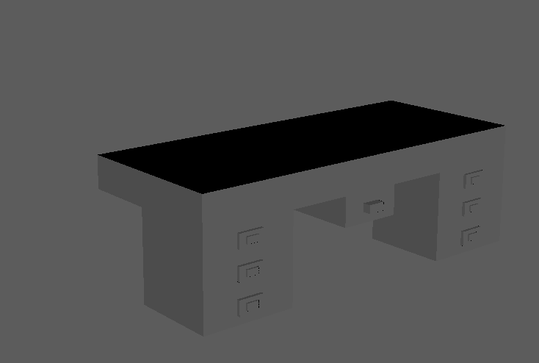

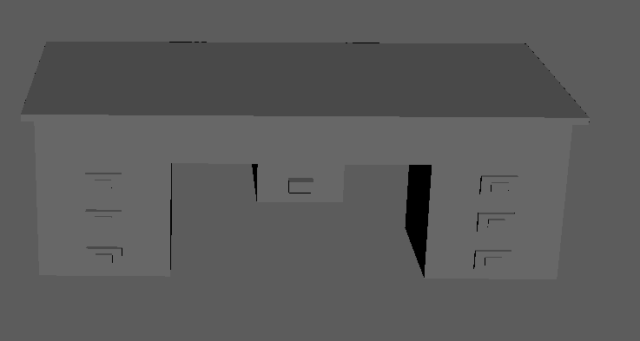

Barrel
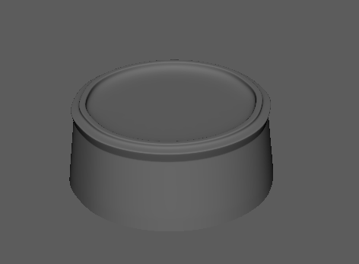

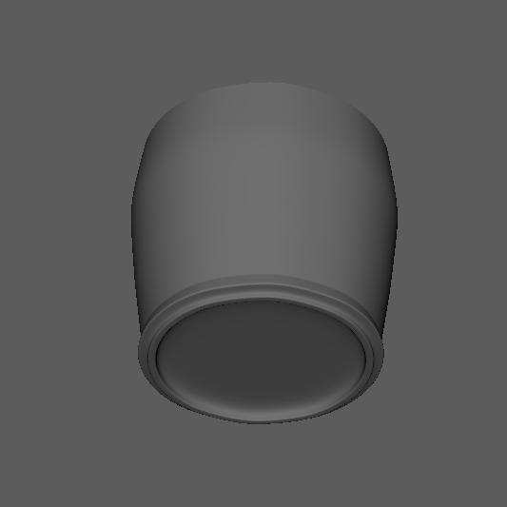

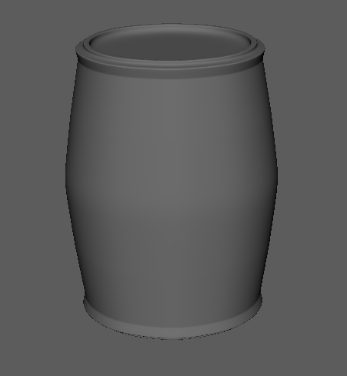

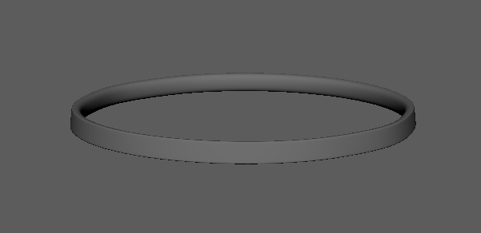

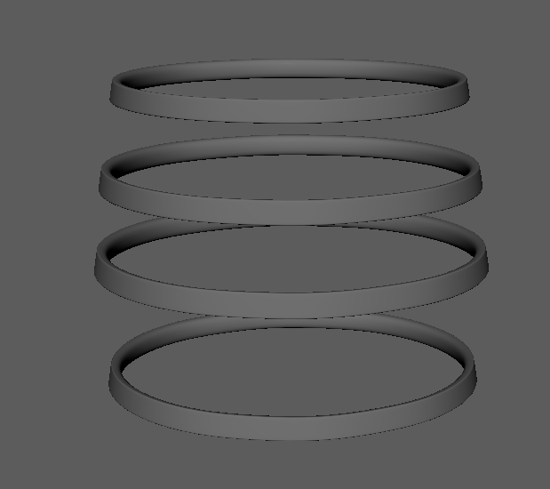

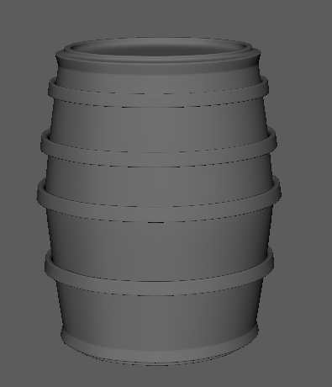

Book
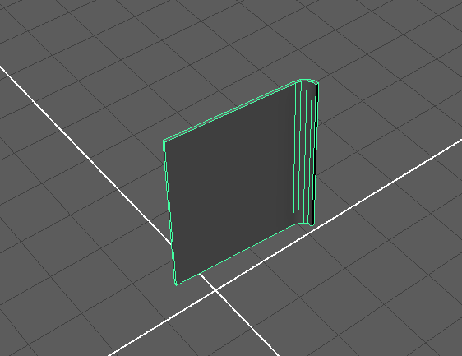

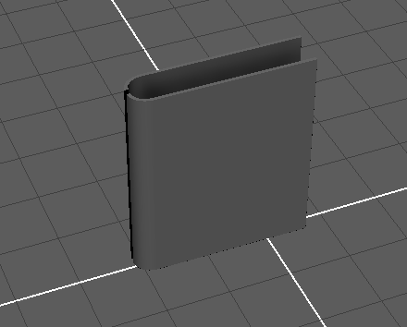

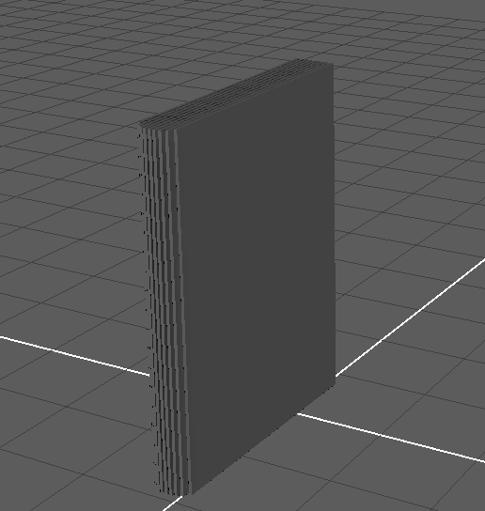

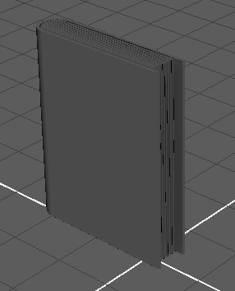

UV unwrapping
Uv unwrapping is one of the most important process of in the 3d production pipeline for the process of UV unwrapping I used maya’s Automatic Uv unwrapping

Barrel
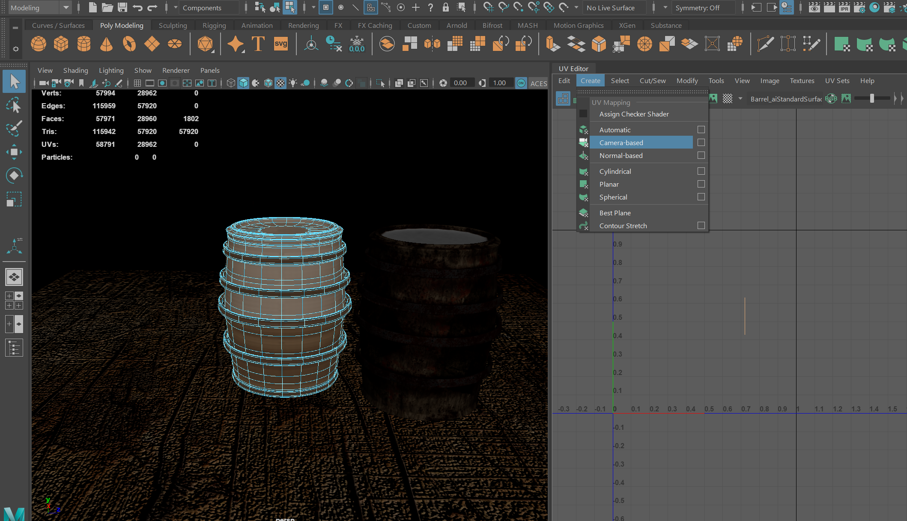

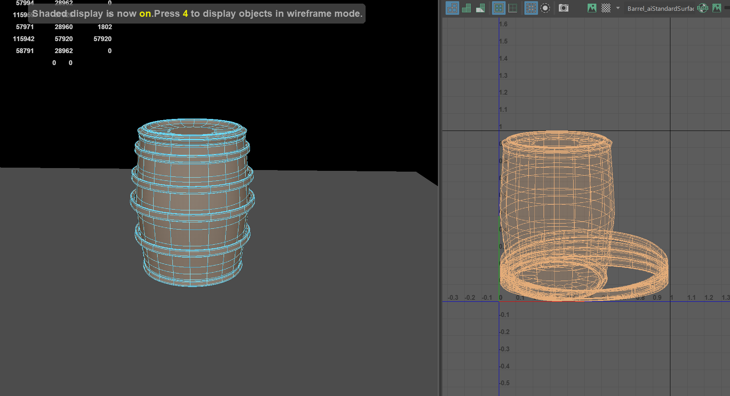

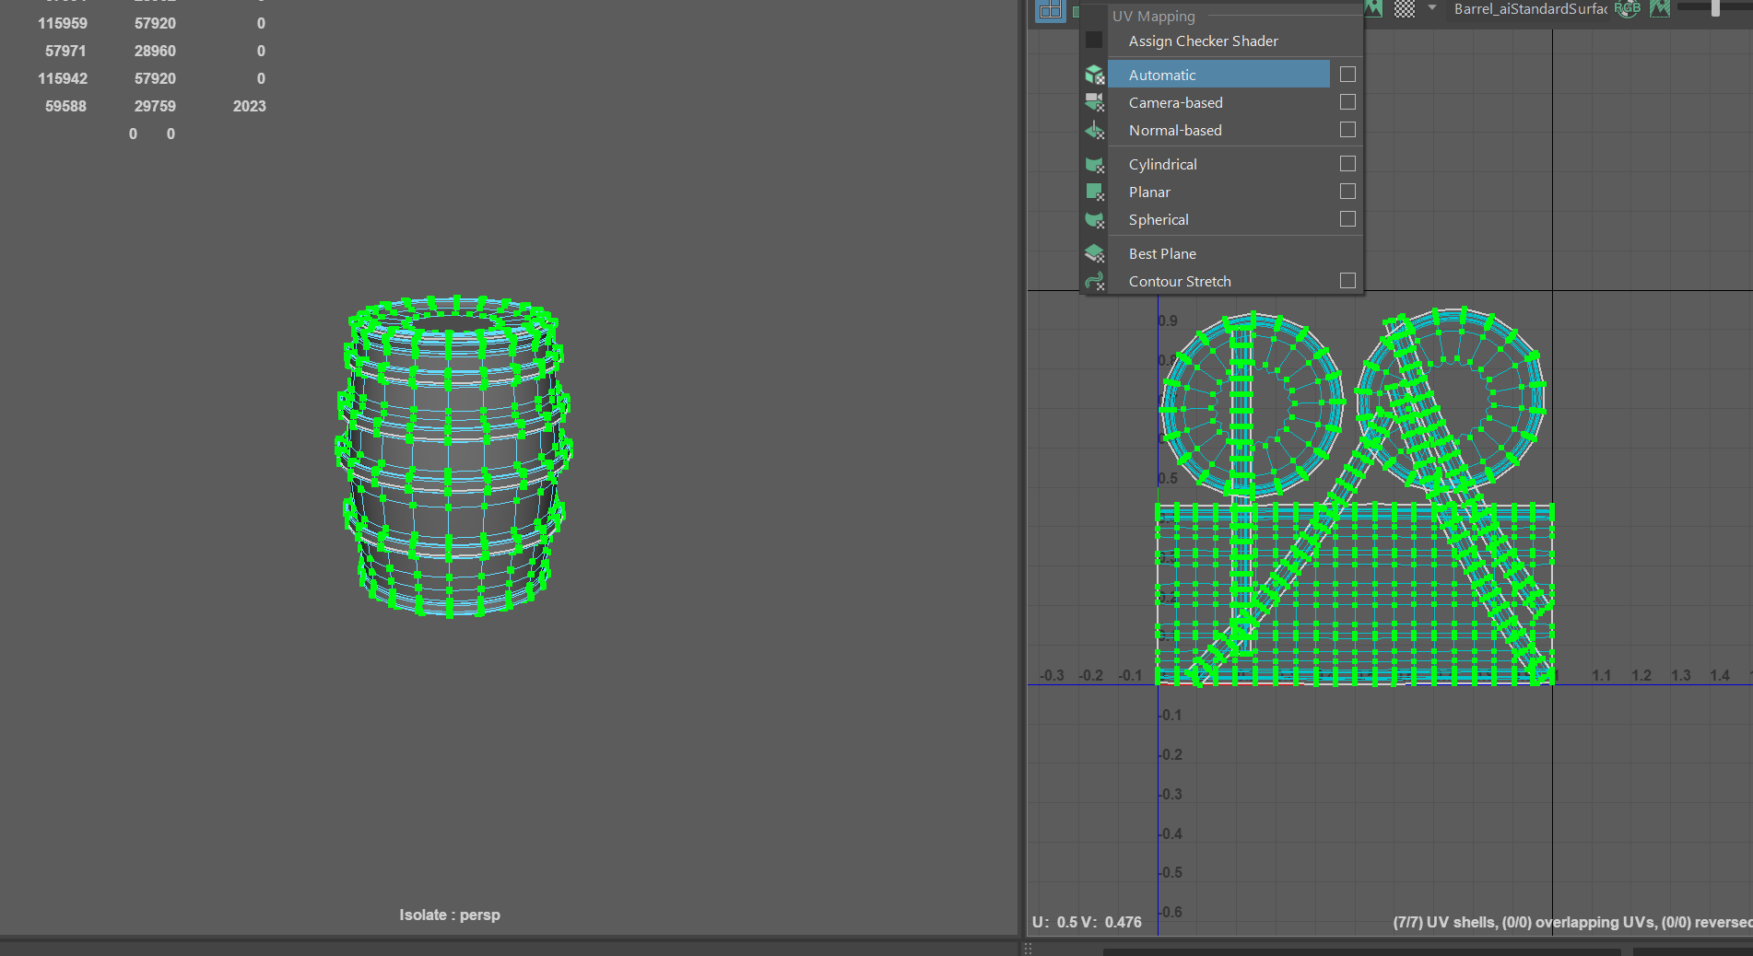

Bar chair

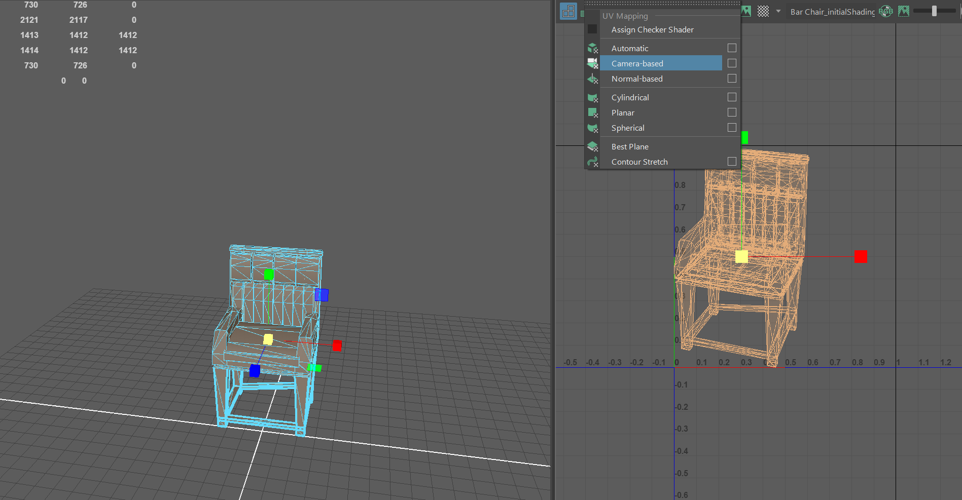

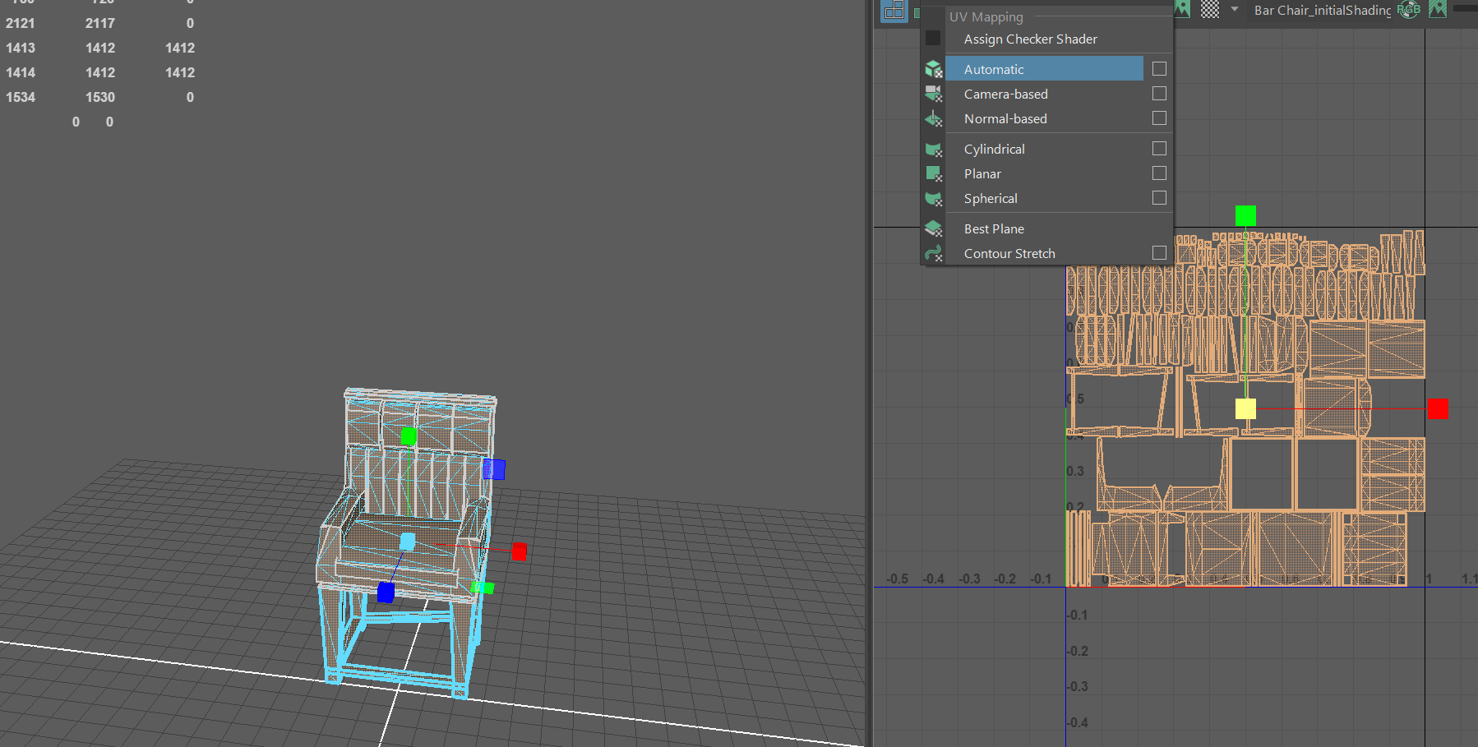

Coffee Table
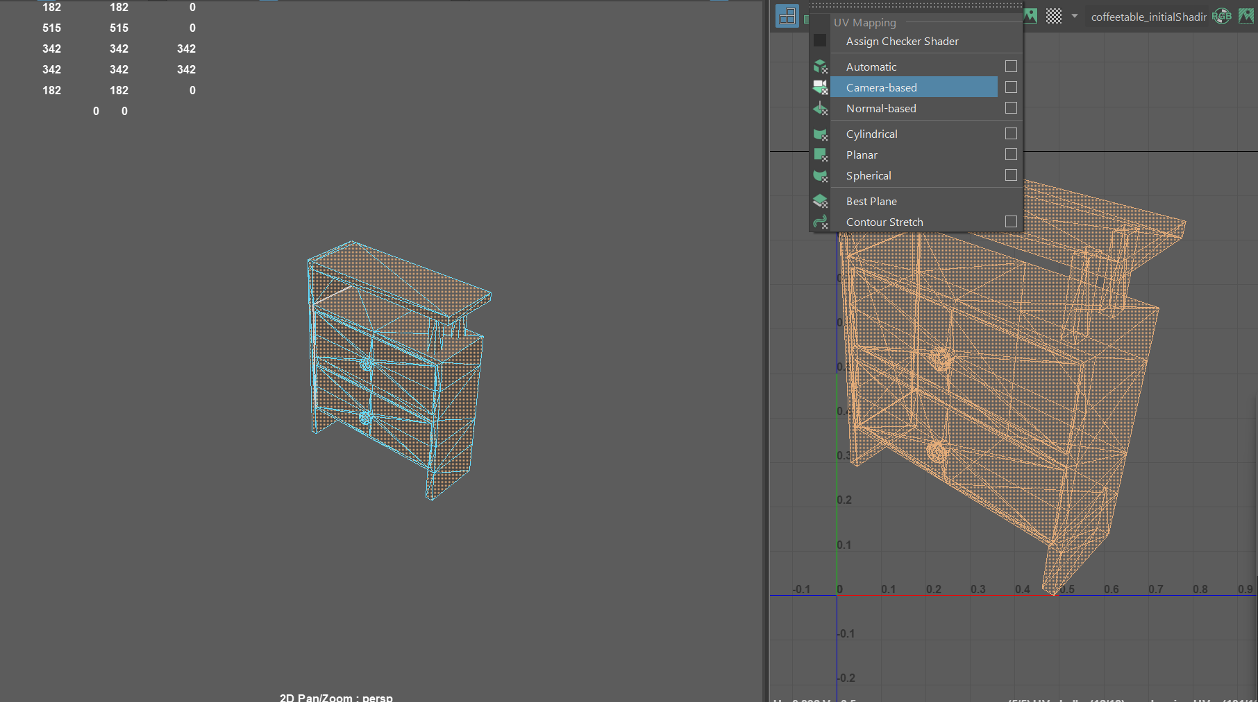

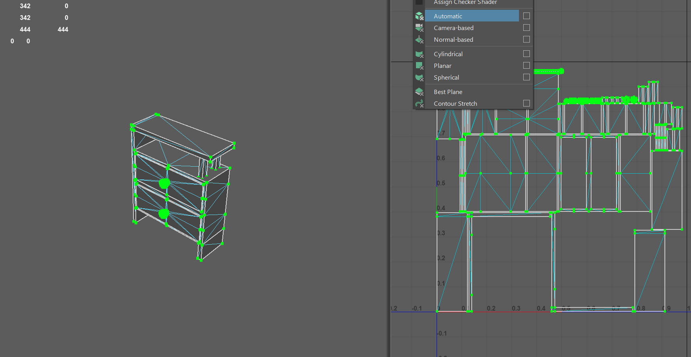

Books
